SCHOOL OF COMPUTER SCIENCE AND ARTIFICIAL INTELLIGENCE |  |  |  |  | DEPARTMENT OF COMPUTER SCIENCE ENGINEERING
Program Name: M. Tech/MCA/MSC |  |  |  | Assignment Type: Lab |  |  | AcademicYear:2025-2026
Course Coordinator Name |  |  |  | Venkataramana Veeramsetty
Course Code |  |  |  | Course Title |  | AI Assisted Problem Solving Using Python
Year/Sem |  |  | II/I | Regulation |  | R24
Date and Day  of Assignment |  |  | Week5- Tuesday | Time(s)
Duration |  |  | 2 Hours | Applicable to  Batches
AssignmentNumber:12.3(Present assignment number) /24(Total number of assignments)
 | Q. No. | Question |  |  |  |  |  | Expected Time  to complete
 | 1 | Lab 12 – Algorithms with AI Assistance: Sorting, searching, and optimizing algorithms  Lab Objectives  - To implement classical algorithms (sorting, searching) with the help of AI tools.  - To analyze AI suggestions for efficiency and correctness.  - To explore AI-assisted optimizations of existing algorithms.  - To compare naive vs. optimized approaches generated by AI.  Learning Outcomes  After completing this lab, students will be able to:  • Implement sorting and searching algorithms using AI suggestions.  • Compare AI-generated algorithm variants in terms of readability and efficiency.  • Use AI to optimize brute-force algorithms into more efficient ones.  • Analyze algorithm complexity (time and space) with AI explanations.  • Critically reflect on correctness, clarity, and maintainability of AI-generated algorithms.  Task Description #1 – Linear Search implementation  Task: Write python code for linear_search () function to search a value in a list and extract its index.  INPUT:  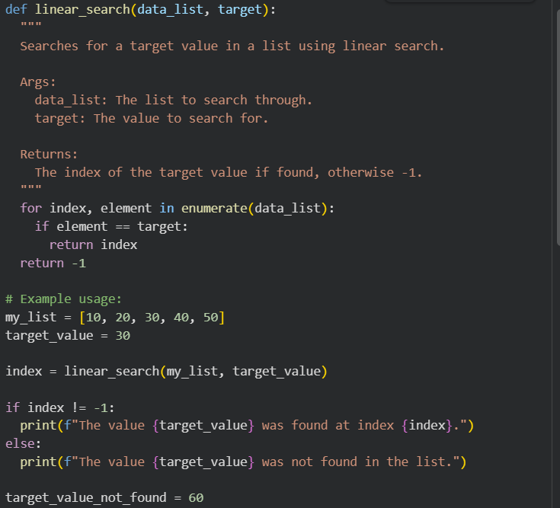  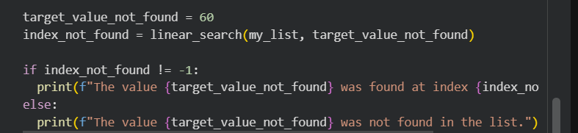  OUTPUT:  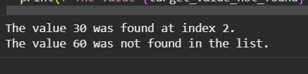  Task Description #2 – Sorting Algorithms  Task: Ask AI to implement Bubble Sort and check sorted output  INPUT:  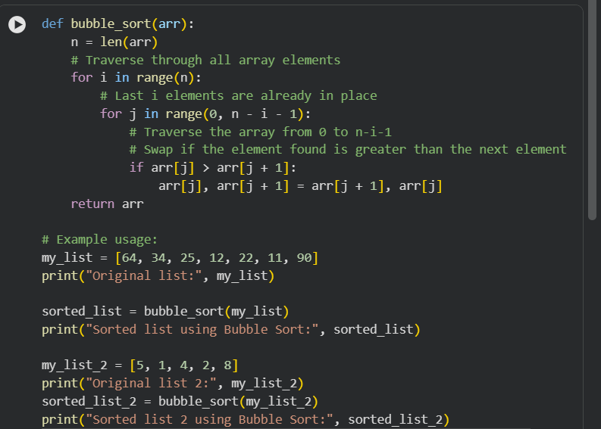  OUTPUT:  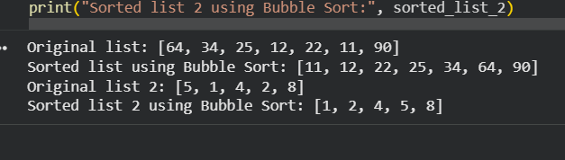  Task Description #3 – Optimization  Task: Write python code to solve below case study using linear optimization    INPUT:  @@ -0,0 +1,24 @@  from pulp import LpMaximize, LpProblem, LpVariable, value  # Define the optimization problem  model = LpProblem("Chocolate_Profit_Maximization", LpMaximize)  # Define decision variables  x = LpVariable("Chocolate_A", lowBound=0, cat='Integer')  y = LpVariable("Chocolate_B", lowBound=0, cat='Integer')  # Add constraints  model += x + y <= 5 # Milk constraint  model += 3*x + 2*y <= 12 # Choco constraint  # Define objective function  model += 6*x + 5*y # Profit function  # Solve the problem  model.solve()  # Output results  print("Optimal Production Plan:")  print(f"Produce {int(x.value())} units of Chocolate A")  print(f"Produce {int(y.value())} units of Chocolate B")  print(f"Maximum Profit: Rs {int(value(model.objective))}")  OUTPUT:  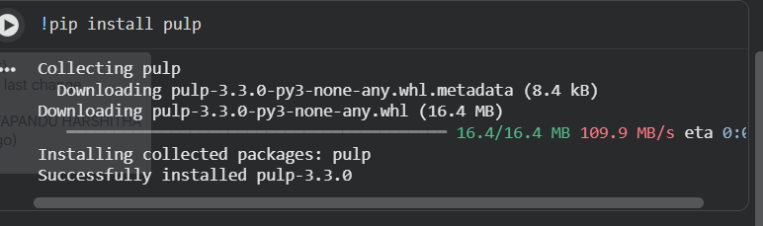  Task Description #4 – Gradient Descent Optimization  Task: Write python code to find value of x at which the function f(x)=2X³+4x+5 will be minimum  INPUT:  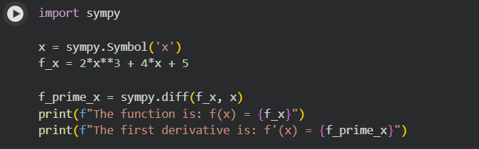  OUTPUT:  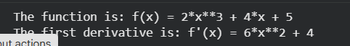  THANKYOU |  |  |  |  |  | Week5- Tuesday

